Area of Learning (EHCP & ILPs) | Activity | Resources & Web links | Additional information
Communication | 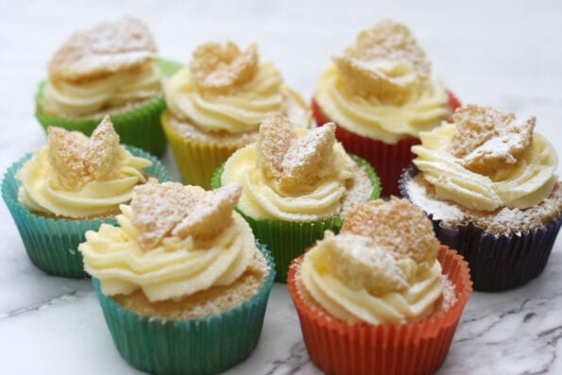  Making butterfly cakes  Make some butterfly cakes with your child. Get your child to collect all the ingredients and equipment that are needed to make these cakes.  Encourage your child to be independent as possible when making these but supervise at all times.  When these cakes are done get your child to give them a family member or a friend. | https://www.bbcgoodfood.com/recipes/butterfly-cakes  Communication board - See separate file: https://fairfields.northants.sch.uk/files/238/240521/719/cake-comms-board.pdf  Method communication board - See separate file:  https://fairfields.northants.sch.uk/files/238/240521/720/method-comms-board-.pdf  Ingredients  110g butter , softened  110g caster sugar  2 eggs  1 tsp vanilla extract  - 110g self-raising flour  - ½ tsp baking powder  - 1 tbsp milk , plus 2 tbsp if needed, to loosen the buttercream  - strawberry jam (optional)  - sprinkles (optional)  For the buttercream  300g icing sugar  150g butter , softened | Care to be taken near the hot oven and when using a knife and also allergies to ingredients to be considered.
Cognition & Learning | Letters using natural objects –  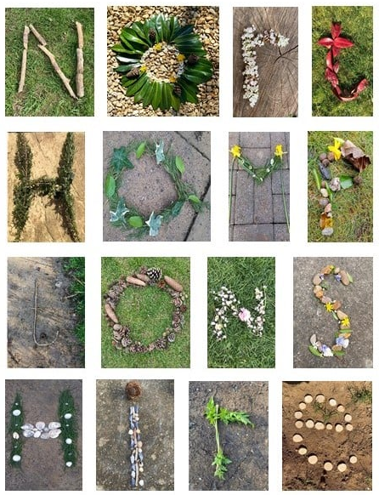  Whilst exploring your garden or outside space, find lots of natural objects and investigate these:  - Sort them by colour, shape, size, number of petals or leaves etc.  - Use these objects to form numbers or letters e.g. name.  - Use the natural objects to form a picture on the floor.  Extension – Have any bugs and creepy crawlies been spotted? Watch them and discuss their colour, shape and how many legs, spots and wings they have. | No equipment needed | Ensure hands are washed after handling natural objects and insects
Phy/Sensory & Independence | Scented playdough  Follow the Oranges and Lemons Playdough Recipe to make some scented playdough. Support your child to make the playdough together, mixing the dry ingredients together and exploring the smell of the ingredients as you add them in.  Once the dough has cooled, encourage your child to play with the playdough and explore the scent of it in their play. | Link to Oranges and Lemons Playdough Recipe: https://fairfields.northants.sch.uk/files/252/280621/765/Oranges-and-Lemons-Playdough-Recipe.pdf | You can adapt the smell by changing the flavour of the jelly powder you use in the playdough.  This recipe is safe if your child like to explore with their mouth.
SEMH | Blowing bubbles.  Bubbles are lots of fun and have the added benefit of using deep breathes that are required for relaxing. Play the Slow Things Down song whilst blowing bubbles. Practise taking 5 deep breathes together and ticking them off the Deep Breathes Chart. | 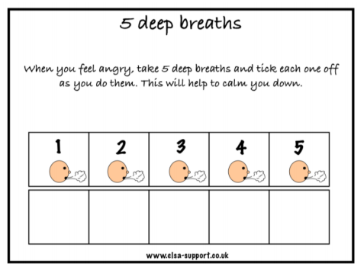  https://www.youtube.com/watch?v=S3cO6Okk-EM | Use the Slow Things Down song at a quiet and calm time during the day. If your child is angry or confused, you can encourage them to use the deep breathing skills that they learn during calmer times.  https://fairfields.northants.sch.uk/files/258/050721/775/Deep-Breathes-Chart.pdf

