Chair of Governors Letter
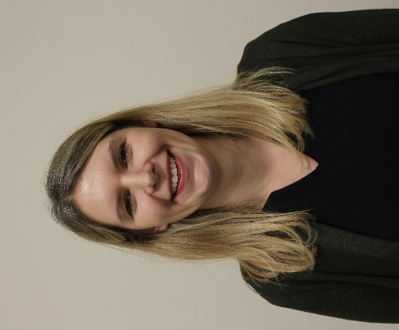
Dear Parent (s) and Carer(s),
I am writing to introduce myself as Chair of Governors at Fairfield’s Primary School. I have been a Governor at Fairfield’s for just over a year and enjoy coming into school to meet with both the children and staff.
I am a primary school teacher so have a good understanding of education and SEND, having worked with and continuing to work with a variety of different needs. I am passionate about education and every child having a right to education.
Fairfield’s is committed to providing the best education for each individual child at their school. As a Governor, I regularly come into school and it is clear to see that the following beliefs are embedded into every day practise with every individual child supported in their learning journey.
What is the role of the governors?
The governing body has three core roles that we follow:
Ensuring clarity of Vision, Ethos and Strategy
The vision is what the school aspires to. The ethos is the culture and character of the school and the shared beliefs that you all hold. The strategy is the specific actions that are taken to achieve the vision. As governors we ensure there is a clear vision in place and check how it is being fulfilled.
Holding Executive Leaders to Account
Leaders in school make decisions about day-to-day operations, and governors evaluate how effectively leaders have exercised their professional judgement. Leaders in schools decide how to spend the budget, and governor’s review whether the school has achieved value for money. School leaders manage individual staff members, and governors assess staff's performance as a whole.

Overseeing Financial Performance
As governors we will check that school management systems are effective and complaint. We will regularly monitor the budget and check that the school is delivering value for money. Alongside this we will check policies are up to date and are being followed in school.

The governing body at Fairfield’s are truly committed to supporting Mrs Elder and the team in leading the school forward with every individual child are the forefront. I look forward to meeting you at different parent events in school.

Yours Sincerely,

Mrs Katie Usher
Chair of Governors

